**Hi All.**  
You need to develop a page as shown in <http://junioriit.com>  
Try to make these type of page. Go through the 4 videos mentioned in “Resources file”.  
  
**Hint** for Starting:  
make 3 divs for

1. main (it’ll contain 3 headings)
2. About Us
3. Contact us

If you have any problem msg it on group, We’ll help you.  
  
COMMON PROBLEM:  
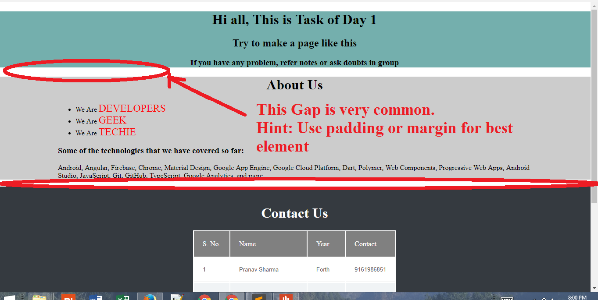

Hint: Use Padding, Margin.  
This is all. **Start Developing**

We will post solution of this web page by tomorrow 5pm. If you feel that you have doubts or want to take classes again, come tomorrow in LT5 @12:30-2:30.  
  
PS. You can also use inspect element of <http://junioriit.com> for reference ;)